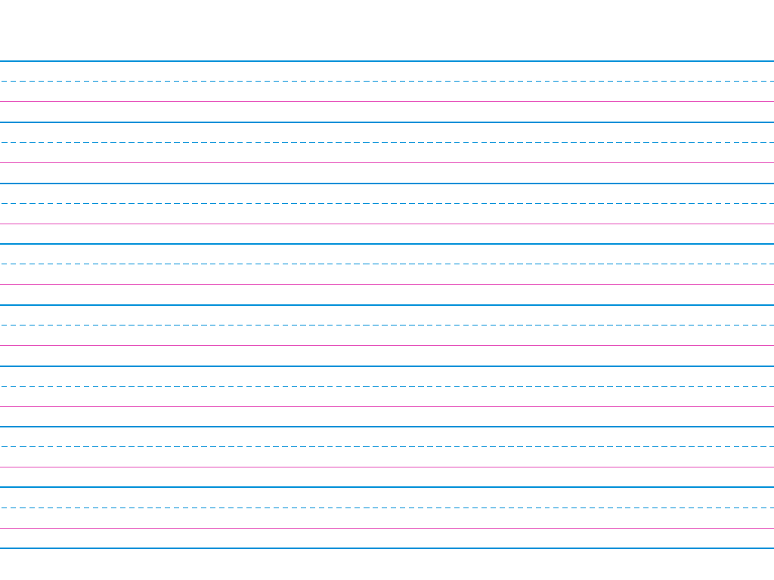

|  |  |  |  |  |
| --- | --- | --- | --- | --- |
| Spaces | Capitals | Punctuation | Spelling  ​​ | Does it make sense? |
|  |  |  |  |  |