Editable Exemplar Rubrics

These rubrics are meant to help you create or select high-quality rubrics to accompany your writing instruction. We provided one per grade level, K-3, and covered different genres you might teach. They are based on the Common Core Standards for writing for each grade, grade-appropriate conventions and genre-specific teaching points. Feel free to adapt and modify as needed. Keep it simple and developmentally appropriate.

Informational Writing Rubric (Kindergarten)
 | 1 | 2 | 3 | 4
Name the topic | I forgot to name my topic.  ☹️ |  |  | I named my topic.  😊
Add details about the topic | I forgot to include details.  ☹️ | I included 1 or 2 details.  😕 | I included 3 details.  🙂 | I included 4 or more details.  😊
Capital Letters  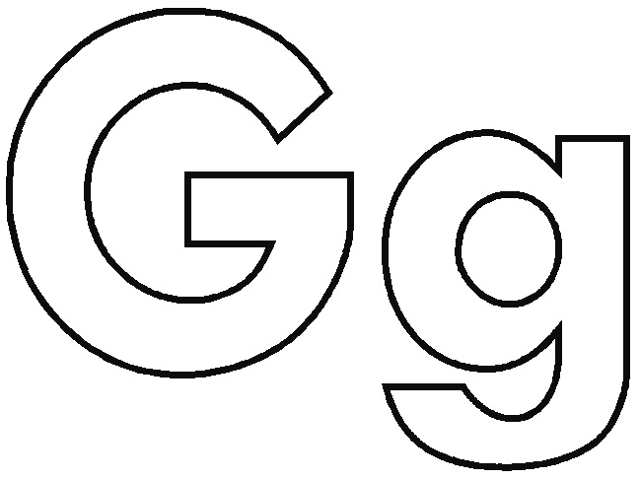 | I forgot all my capital letters.  ☹️ | I forgot most of my capital letters.  😕 | I forgot one or two capital letters.  🙂 | I didn’t forget any capital letters.  😊
Spaces | I forgot all my spaces.  ☹️ | I forgot most of my spaces.  😕 | I forgot one or two spaces.  🙂 | I didn’t forget any spaces.  😊
Punctuation  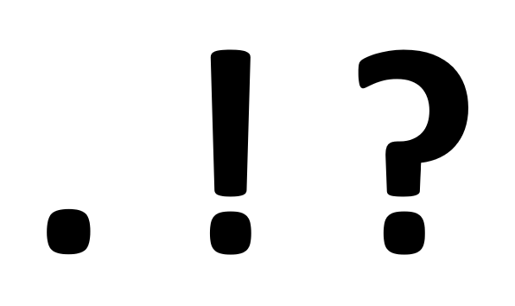 | I forgot all my periods.  ☹️ | I forgot most of my periods.  😕 | I forgot 1 or 2 periods.  🙂 | I didn’t forget any periods.  😊
Opinion Writing Rubric (1st Grade)
 | 1 ☹️ | 2 😕 | 3 🙂 | 4😊
Name the topic | I forgot to name my topic. |  |  | I named my topic!
State my opinion | I forgot to state my opinion. |  |  | I stated my opinion!
Explain your opinion | I forgot to explain my opinion. | I tried to explain my opinion. | I explained my opinion. | I explained my opinion with convincing details!
Write a conclusion | I forgot to write a conclusion. | I tried to write a conclusion. | I wrote a conclusion that said my opinion. | I wrote a conclusion that said my opinion in a different way!
Did you tap out sound it out words? | I forgot to tap out sound it out words. | I tapped out one or two sound it out words. | I tapped out almost all of my sound it out words. | I tapped out all of my sound it out words!
Did you use your best handwriting? | My handwriting is too hard for you to read. | You can read my handwriting but it is hard. | You can read my handwriting. | I used my best handwriting!
Did you  use capital letters and periods? | I forgot most of my capital letters and periods. | I forgot at least 4 capital letters or periods. | I only forgot 1 or 2 capital letters or periods. | I didn’t forget any capital letters or periods!

Persuasive Letter Writing Rubric (2nd Grade)
 | 1 | 2 | 3 | 4
Introduction Sentence | I didn’t include an introduction sentence | I included an introduction sentence but it was confusing or didn’t include my opinion. | My introduction sentence included my opinion. | My introduction sentence included my opinion and made the reader want to know more.
2 Reasons | I didn’t include any reasons. | I included one reason. | I included two or more reasons. | I included two or more convincing reasons.
Explain or give examples for your reasons | I didn’t explain my reasons or give examples. | I attempted to explain my reasons or give examples but they were unclear. | I explained my reasons or gave examples. | I explained my reasons or gave examples that made my letter more persuasive.
Conclusion | I didn’t write a conclusion sentence. | I attempted to write a conclusion sentence. | I wrote a conclusion sentence that restated my opinion. | I wrote a conclusion sentence that restated my opinion in a different way.
Did you use transition words? | I did not use transition words. | I attempted to use transition words. | I used transition words. | I used a variety of transition words.
Did you use your neatest handwriting? | My handwriting is messy and cannot be read. | Most of my work is messy and can be read, but it is challenging. | I have mostly neat handwriting. | I used my neatest handwriting.
Did you  use capital letters and ending punctuation? | I forgot a lot of  capital letters and punctuation  marks. | I made at least 4  mistakes on capitalization or punctuation. | I only made 1 or 2 mistakes on capitalization or punctuation. | I didn’t forget any capital letters or punctuation  marks!
Narrative Writing Rubric (Grade 3)
 | 1 | 2 | 3 | 4
Did you orient the reader to the situation, setting and characters? | I didn’t orient the reader to the situation. | I attempted to orient the reader to the situation but the characters and/or setting were unclear. | I oriented the reader to the situation, the setting and the characters. | I oriented the reader to the situation, the setting and the characters by showing not telling.
Did you include three or more events that were connected? | I didn’t include three or more events. | I included some events but it was unclear how they were connected. | I included three or more connected events. | I included three or more events that were clearly and logically connected.
Does your character have a problem? Does the ending include a solution? | My story didn’t include a problem.  I didn’t write an ending. | The problem was unclear. I attempted to write an ending. | The problem was clear.  I wrote an ending where the problem was solved. | I wrote an ending where the problem was solved that made the reader feel/think.
Did you use transition words and phrases? | I did not use transition words and phrases. | I attempted to use transition words and phrases but it was unclear what happened when. | I used transition words and phrases to show what happened when. | I used a variety of transition words and phrases to show what happened when.
Did you spell most of the words right? | I made a lot of  spelling mistakes. | I made a few  spelling mistakes. | I only misspelled one or two words. | I didn’t make any spelling mistakes!
Did you remember capital letters and punctuation marks? | I forgot a lot of  capital letters and punctuation  marks. | I made at least 4 capital letter or punctuation  mistakes. | I only made 1 or 2 capitalization or punctuation  mistakes. | I didn’t forget any capital letters or punctuation  marks!

